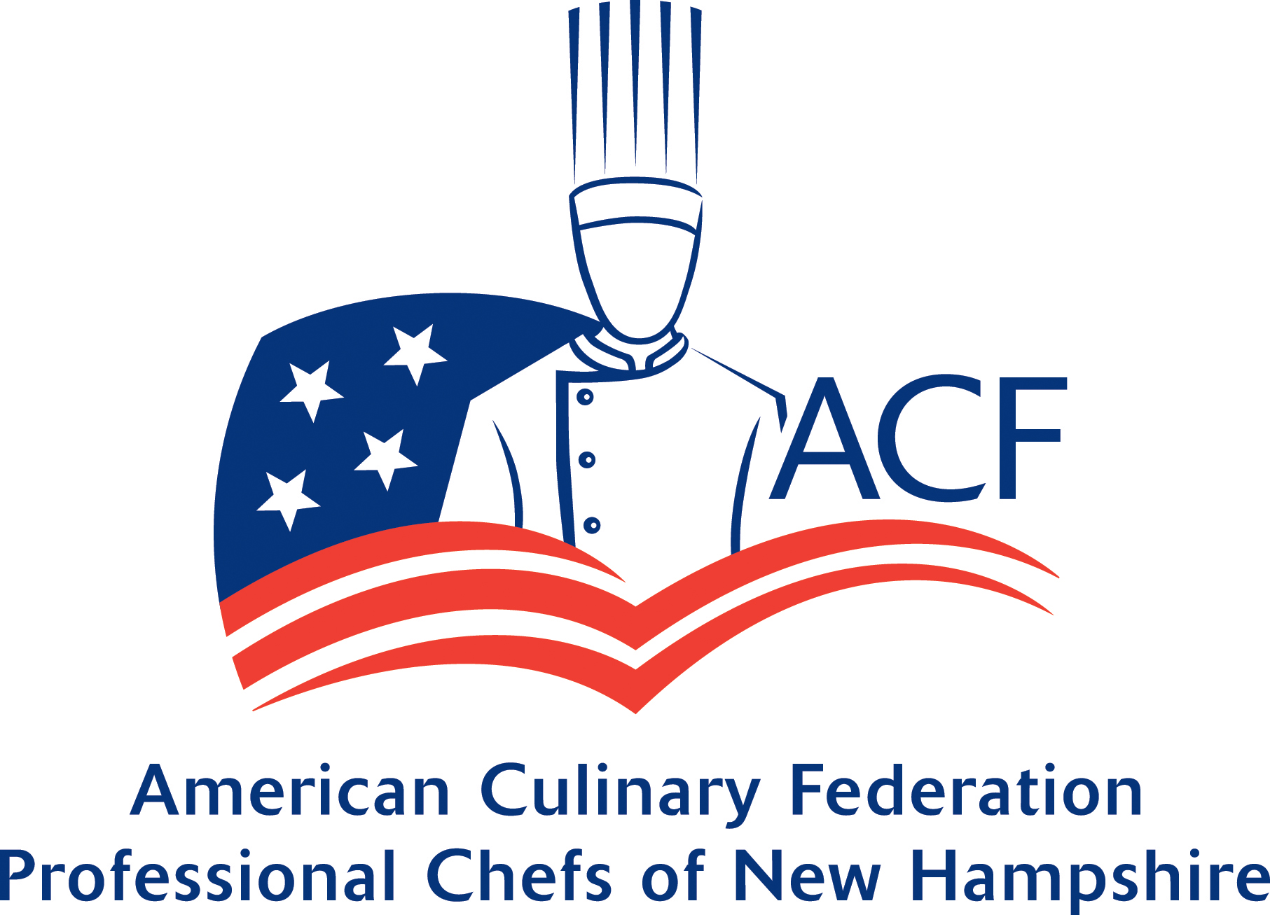
The ACF-PCNH would like to assist its members with continuing education. Each year the Board of Directors will assess funds available and will designate an amount towards educational reimbursement for its members. The reimbursement must be applied for each year. The amount will be determined by the number of points accumulated by each member. Eligible activities will include: Epicurean Evening, Holiday stroll, and other events as approved by the Board. Any member in good standing may apply for the reimbursement at the January or February meeting to be part of the program for 2025. Any funds not used by the member during 2025 cannot be rolled over into the following year. The funds will return to the educational budget to be re-allocated in 2026.
A twelve-point minimum is required to qualify (see point system). The amount will be determined as follows: Available funds divided by aggregate points = value per share. Individual points x value per share = individual reimbursement amount.

Name _________________________________ Phone ________________
# of Meetings attended ___________@1 pt each
# of Meetings hosted _________@ 1 pt each
# of Demos __________@ 2 pts each
Committees __________________________@ 2 pts each
Or Board Position ______________________
__________________________
Chapter Activities @2 pts each
________________________________________________________ ________________________________________________________ Other Board Pre-approved Activities
______________________________________

