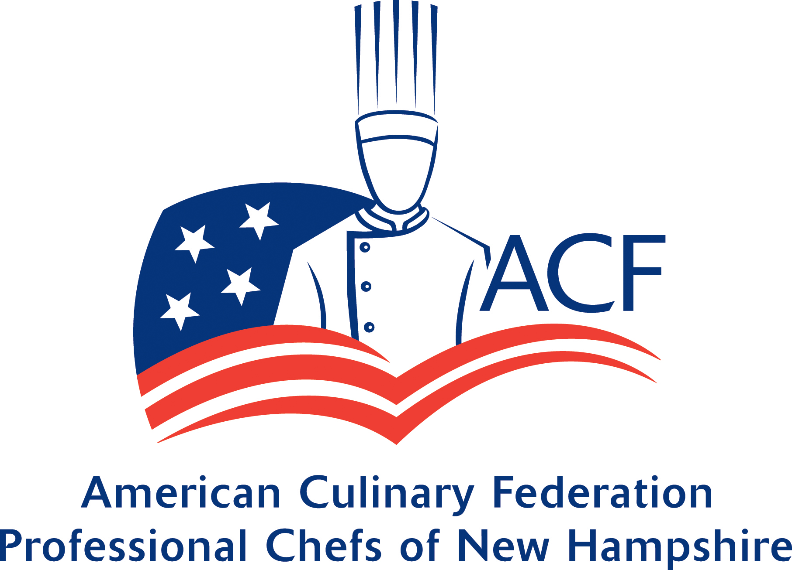

APPLICATION FOR SCHOLARSHIP ASSISTANCE
Please return with all required information by February 15, 2025

NAME_______________________________________________ DATE__________

ADDRESS_______________________________________ PHONE______________

_______________________________________

EMAIL _______________________________________

SCHOOL CURRENTLY ATTENDING_______________________________________

ADDRESS_______________________________________

_______________________________________

NUMBER OF SEMESTERS COMPLETED___________

PREVIOUS SCHOOL ATTENDED__________________________________

NUMBER OF SEMESTERS COMPLETED____________
(High School Students need not fill out Previous School Attended)

SCHOOL APPLYING TO ______________________________________

ADDRESS________________________________________

________________________________________

ARE YOU A MEMBER OF THE ACF? YES NO

HOW LONG? ____________ WHICH CHAPTER _______________________

MEMBERSHIP NUMBER_____________________
For Verification Purposes
DID YOU ATTEND A 2024 ACF REGIONAL EVENT? _________

DID YOU ATTEND 2024 ACF NATIONAL CONVENTION? ________

PLEASE LIST ACF ACTIVITIES PARTICIPATED IN FOR CALENDAR YEAR 2024

1.) _________________________________________________

2.) _________________________________________________

3.) _________________________________________________

4.) _________________________________________________

5.) _________________________________________________

APPLICATION MUST BE SUBMITTED WITH THE FOLLOWING:

- A COPY OF YOUR SCHOLASTIC TRANSCRIPT

2.) 250 WORD ESSAY ABOUT WHAT BROUGHT YOU TO CULINARY OR WHO INFLUENCED YOU INTO CULINARY OR WHY YOU HAVE A PASSION FOR CULINARY

- TWO LETTERS OF PROFESSIONAL RECOMMENDATION
(Non family members)

_______________________________ _____________________

APPLICANT’S SIGNATURE DATE

SUBMIT TO:
ACF- Professional Chefs of NH
PO Box 4477
Manchester, NH 03108

